8 bit Microprocessor Design
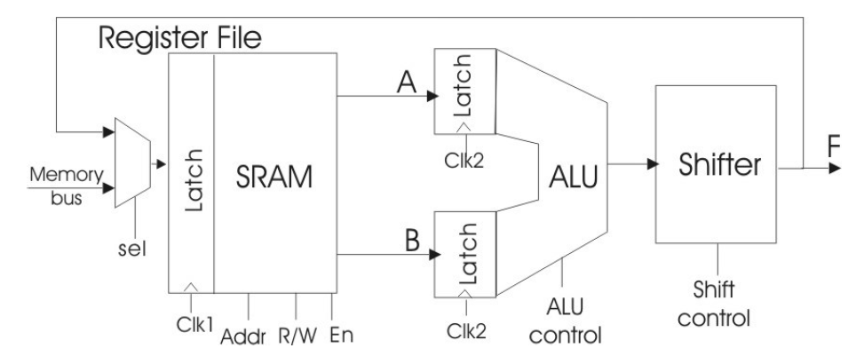

1. ALU
We need…
- Inputs: A[0:7], B[0:7], Control Signal (Selecting Functions), Clk2
- Internal:
  - 8bit Adder, Increment, Subtractor (A+(-B)) – Manchester Carry Chain Adder
  - Logic Unit (AND, OR, XOR?)
  - Shifter
- Outputs: 8bit Results

- AND, OR, XOR, NAND, NOR 등 게이트 크기 최소화

